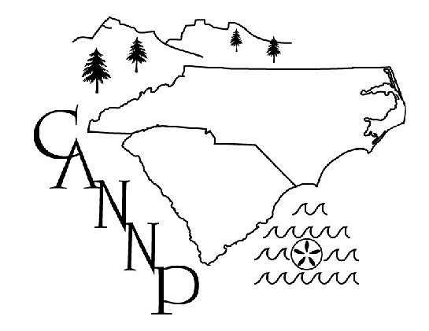
Carolinas Association of Neonatal Nurse Practitioners
2022 Annual Business Meeting

Tuesday April 12, 2022

Welcome and Introduction
Stephanie Blake, President. Thanked outgoing President and continuing IT and website supporter Patrick Connelly for their service. Introduced the 2022-2023 board members (see * attached).

Review of Minutes
Stephanie Blake, President emailed minutes to current members. Amy Jnah made motion to approve and these were accepted with no corrections.

Treasurer’s Report
Amy Jnah, Treasurer. Reported current bank account balance prior to conference costs. Sharon Rush will send checks and Thank you notes to 2022 Speakers..

Membership Report
Sharon Rush, Vice President with Kathy Connelly, Executive member.
36 current members for 2022. 34 conference registrations received.

Member-at-Large/Media Report
Jennifer Porter, Member-at-Large. Discussed options for maintaining social media news and updates. Currently, the CANNP Facebook account is only viewable by members and only had ~30 views for latest post. “Gray” Facebook accounts going away 4/22; would be an ideal time to make new page.
Other social media suggestions: Instagram, LinkedIn; Jenny will look into adding

Awards
Amy Jnah, Treasurer- none this year (virtual again due to Covid cases)

Old Business
Website- Patrick Connelly will continue to manage
Poster presenters- received stipend divided evenly among presenters

New Business
2023 Conference Planning:
-options: Great Wolf Lodge or local site near Durham/Chapel HIll
-will send survey to past/current members about location preference
-Next conference March 2023
-Live (determine site by July, 2022)
-Ask NCNA about recorded format also for those unable to attend in person
-Judy Philbrook has done live+virtual conference and kept 2 rosters for NCNA
-Stephanie and Kristi to visit potential conference sites

Website and merge from Gmail account
-Patrick planning to add Board member accounts to website and eliminate gmail account

Open discussion
-Survey to past/current members and registrants
-include 3 options for conference location
-use Survey Monkey due to security filter issues with Google docs

Next meeting: Aug/Sept (after conference site for 2023 is determined)
-
Adjournment

*New Board Members and Transitions:

President- Stephanie Blake moved into role from Secretary
Vice-President- Sharon Rush moved into role from Treasurer
Treasurer: Amy Jnah moved into role
Secretary: Kristi Coe elected to role
Member at Large: Jenny Porter
Executive Member: Kathy Connelly moved to role from President

Attendees via Zoom: Stephanie Blake, Kristi Coe, Judy Philbrook, Kathy Connelly, Amy Jnah, Felicia Soza, Sharon Rush, Jenny Porter

2022 Treasurer’s Report

Balance
Bank of America $ 41,172.07

2022 Membership Report

2022 Membership total 36

2021 Membership total 48

2020 Membership total 30

2019 Membership total 52

2018 Membership total 48

2017 Membership total 55

2016 Membership total 52

2015 Membership total 40

2014 Membership total 46

