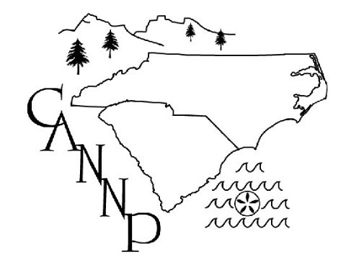
Carolinas Association of Neonatal Nurse Practitioners
2021 Annual Business Meeting

April 14, 2021

Welcome and Introduction
Kathy Connelly, President. Introduced the 2020-2021 members of the board

Review of Minutes
Stephanie Blake, Secretary. Minutes were posted online from 2019, as conference cancelled in 2020. No corrections. Minutes approved

Treasurer’s Report
Sharon Rush, Treasurer. Separate report of finances and website costs discussed. Current bank account balance reviewed; total conference costs discussed. All monies returned from GWL

Membership Report
Sharon Rush, Treasurer. Majority of membership renewed and new sign up through conference this year. > 55 conference registration this year
- Request to continue live and virtual conference next year. To be looked into as an option. NANN conference Denver Co (both in person and virtual)

Member-at-Large Report
Jennifer, Member-at-Large. Discussion of continued ways to maintain “social” updates through email and Facebook media outlets. Only CANNP members can see Facebook post, plan to make public. CANNP is on NANN website, although no link to join as of yet. Continue to promote CANNP through individual institutions.

Awards
None this year
Available: Educational Grant
Peer recognition: money used for poster presentation
Money available for research grant

Old Business: Continued discussion on how to improve CANNP conference/membership through media outlets below
Newsletter
Website
Social Media
HUS CEU on CANNP website
Desi former member at large has moved on to Baylor

New Business
2021 Conference: Looking for area, would like to move back to RTP area. Virtual/In person: start looking this summer. Plan in the future will be to go back to GWL.
Open discussion: Future goals discussed based on member feedback including different locations. Continue to work on collaboration with ANN, NANN to market CANNP conference on their website.
Board Member Elections: Kathy: President until the end of the year.
Stephanie: Move up to President
Amy: move to treasurer
Sharon: move to VP
Kristie Coe to count ballots
Available positions: Secretary

Next Conference May 2022

Adjournment

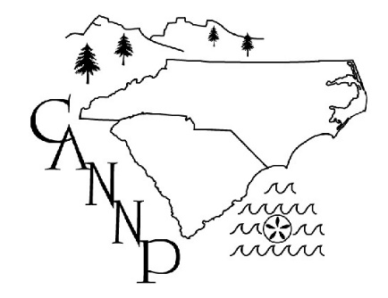

2021 Treasurer’s Report

Balance
Bank of America $38,324.45 as of April 2021 final balance post
conference pending

2021 Membership Report

2021 Membership total 48

2020 Membership total 30

2019 Membership total 52

2018 Membership total 48

2017 Membership total 55

2016 Membership total 52

2015 Membership total 40

2014 Membership total 46

