# 2023 CANNP Research Grant Application

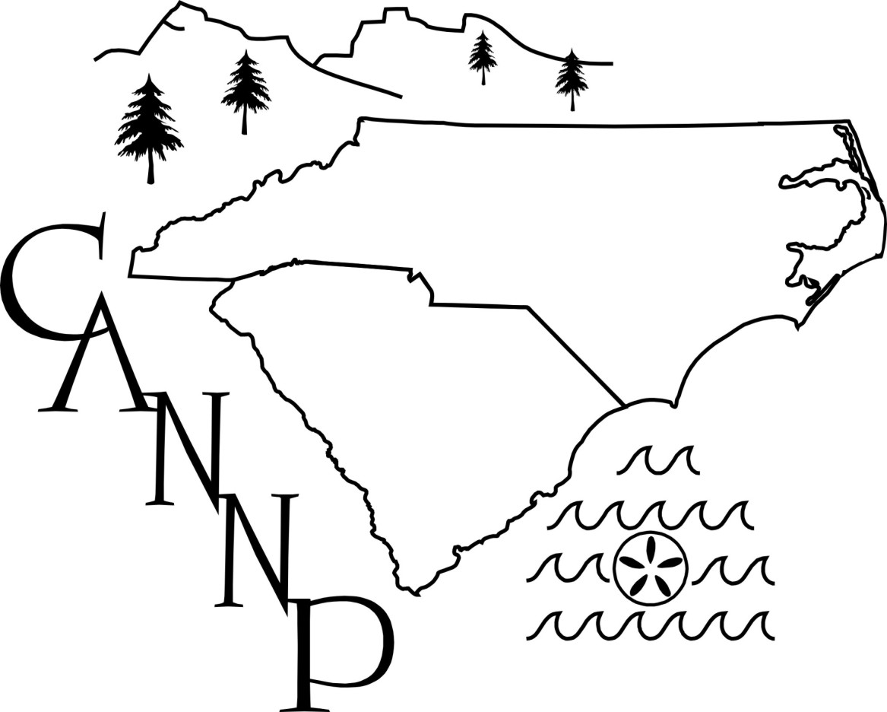

|  |
| --- |
| **Mission of the Carolinas Association of Neonatal Nurse Practitioners:**  1. To establish an organization to facilitate professional development,  education and research for the neonatal nurse practitioner.  2. To provide a communication network for exchange of ideas regarding  practice, education and the professional role of the neonatal nurse  practitioners.  3. To participate in the legislative activities regarding nurse practitioner scope  of practice specifically in the neonatal care area. |

The Carolinas Association of Neonatal Nurse Practitioners (CANNP) offers an annual grant in the amount up to $1,000. We invite all qualified CANNP members at institutions directly supporting NICU(s) to submit a grant application.

Applicants should submit a Letter of Intent addressed to CANNP summarizing the proposed program. Letter of intent should be emailed to Sharon Rush NNP, CANNP Vice President, at carolina.nnps@gmail.com with the subject of “CANNP Research Grant Funding Request”.

**Letters of Intent should be no more than 4 pages and must include the following:**

|  |  |
| --- | --- |
| 1 | Name of the study, amount of requested funds, timeline of the study, PI(s) who will be running the study including their positions/titles/institutions, and a 100-200 word overview describing the objective. |
| 2 | List of specific aim or aims to be evaluated during the study. |
| 3 | The relevance to the CANNP mission |
| 4 | Amount of funding requested, including a basic budget allocation. Funds must directly support the project described. |
| 5 | The hypothesis or hypotheses to be tested. |
| 6 | Preliminary data. |
| 7 | A statement of the methods. |
| 8 | A plan for evaluating the results. |
| 9 | Current financial support: list the current financial support. If there are no other grants, state “NONE.” |

**Letters of intent must be submitted by February 1, 2023. Applications will then be evaluated by the Funding Committee and awards will be announced during the month of March 2023.**

**Individuals who receive the grant award are required to attend the 2024 CANNP conference and submit a poster summary of their research project.**