2023 CANNP Evidence Based Practice/ Quality Improvement Grant Application
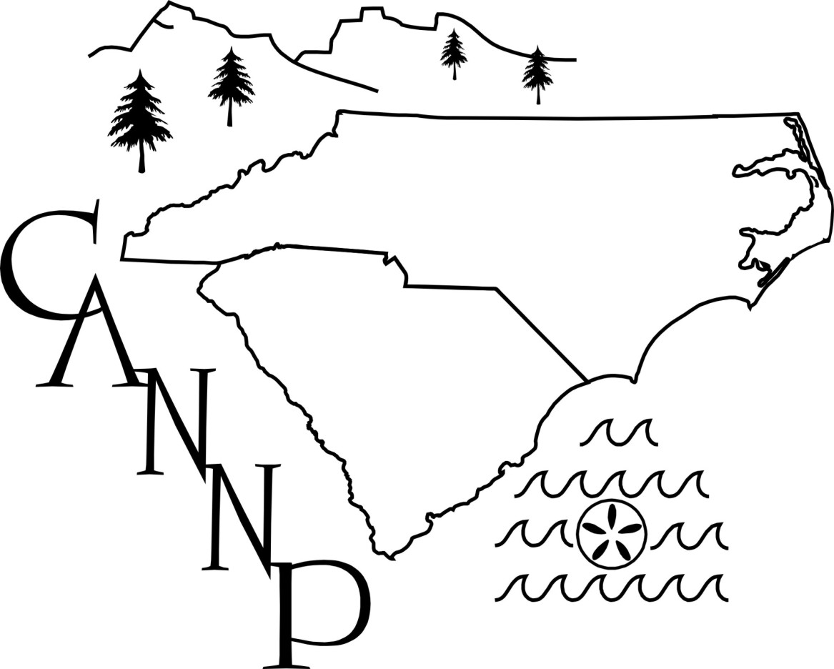
Mission of the Carolinas Association of Neonatal Nurse Practitioners:

The purposes of the ASSOCIATION shall be:
1. To establish an organization to facilitate professional development,
education and research for the neonatal nurse practitioner.
2. To provide a communication network for exchange of ideas regarding
practice, education and the professional role of the neonatal nurse
practitioners.
3. To participate in the legislative activities regarding nurse practitioner scope
of practice specifically in the neonatal care area.

The Carolinas Association of Neonatal Nurse Practitioners (CANNP) is offering Evidence-Based Practice/Quality Improvement grant in the amount up to $1,000 to help make the NICU experience a little easier for families and promote high-quality care and outcomes. We invite all qualified CANNP members at institutions directly supporting NICU(s) to submit a grant application.
Applicants should submit a Letter of Intent addressed to CANNP summarizing the proposed program. Letter of intent should be emailed to Sharon Rush CANNP Vice President at carolina.nnps@gmail.com with the subject of “CANNP EBP/QI Grant Funding Request”.

Letters of Intent should be no more than 4 pages and must include the following:
1 | Title of the program, amount of requested funds, and a 100-200 word overview describing the objective.
2 | The relevance to the CANNP mission
3 | A detailed plan of the proposed program including the hospital/institution(s) that will benefit.
4 | A plan for evaluating the results and providing feedback of success.
5 | Past similar projects. If you have done something similar to this in the past please indicate so.

Letters of intent must be submitted by February 1, 2023. Applications will then be evaluated by the Funding Committee and awards will be announced during the month of March 2023.

Individuals who receive grant awards are required to attend the 2023 CANNP conference and submit a poster.

