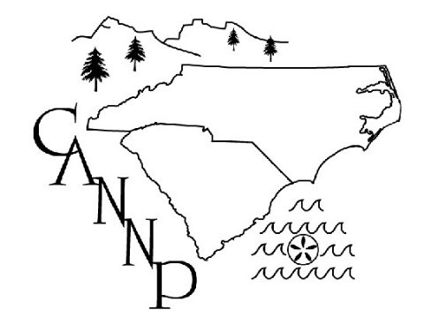
Carolinas Association of Neonatal Nurse Practitioners
2019 Annual Business Meeting

Thursday March. 14, 2019

Welcome and Introduction
Kathy Connelly, President. Introduced the 2018-2019 members of the board

Review of Minutes
Stephanie Blake, Secretary. Minutes were posted at conference. No corrections. Minutes approved

Treasurer’s Report
Sharon Rush, Treasurer. Separate report of finances and website costs discussed. Current bank account balance reviewed, total conference costs pending

Membership Report
Sharon Rush, Treasurer. See attached. Discussed responses from e-mail distribution of membership information and conference announcements. Discussed ease of registration and membership changes implemented after last year’s conference

Member-at-Large Report
Desi Newberry, Member-at-Large. Discussion of continued ways to maintain “social” updates through email and Facebook media outlets. CANNP is on NANN website, although no link to join as of yet. Continue to promote CANNP through individual institutions.

Awards
Amy Jnah, Vice President. 5 poster presentations. Desi Newberry who received the research grant in 2018 presented her poster
Poster Presenters:
Christine Adams BSN, RNC-NIC
Christine Debnam MSN, RNC-NIC
Larissa Gallaway BSN, RNC-NIC
Tara Paterno BSN, RNC-NIC
Sarah Reilly, BSN, RNC-NIC

Old Business: Continued discussion on how to improve CANNP conference/membership through media outlets below
Newsletter
Website
Social Media

New Business
2020 Conference: Next year’s conference to be at different location outside of RDU with plan to return to RDU area in 2021. Discussed returning to Great Wolf Lodge as previous conference attendee numbers were high. CANNP Board will continue to assume oversight and secure podium presenters, vendors and venue. Facebook blast/Web/Email update will follow once dates booked
Open discussion: Future goals discussed based on member feedback including different location beside Hilton when conference back in RDU as venue was small for the amount of attendees. Continue to work on collaboration with ANN, NANN to market CANNP conference on their website

Adjournment

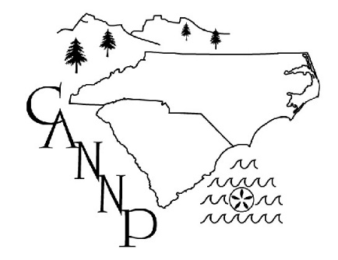

2019 Treasurer’s Report

Balance
Bank of America $ 27,000 as of January 2019 final balance post
conference pending

2019 Membership Report

2019 Membership total 52

2018 Membership total 48

2017 Membership total 55

2016 Membership total 52

2015 Membership total 40

2014 Membership total 46

